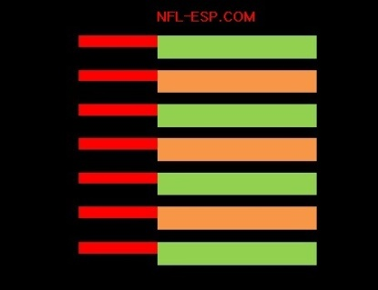
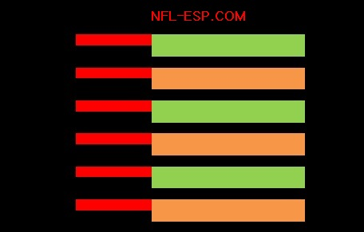
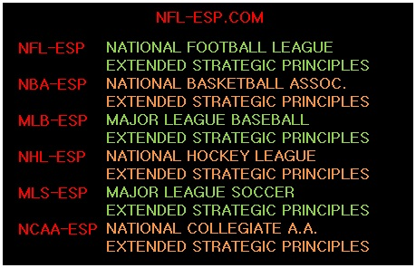
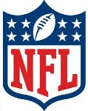

“NFL Moneyball”
[Working Title]
Where would the NFL be without the compliment of shows that add entertainment and insight to the games?
There are studio shows, highlight programs, even fantasy programming; the NBC Sports Network, who brings fans NFL Turning Point, even has a business-minded sports program.
“NFL Moneyball” predicts, reviews, and analyzes the games from the unique perspective of a strategist who has successfully mastered and uses a revolutionary concept called NFL-ESP [Extended Strategic Principles]; and using statistics based on a POWER-RATING and a POWER-SPREAD.
Based in part on the Academy Award® nominated film of the same name; NFL teams seeking a competitive edge, have begun to use such data and form front-office departments seeking such perceptive, fascinating and insightful information.
In addition, while this may, may parallel other widely-distributed numerical information; NFL-ESP’s prized and valuable data and analytical insights can be used by millions-and-millions of other fans who may find this info financially rewarding; not unlike a fantasy football program may lend value to fans decision-making or investments in a fantasy football league; that in itself, a billion-dollar industry.
In the end, “NFL-Moneyball” carries the newfound tradition, which ESPN has further implemented, of featuring former players or personnel who offer professional and personal perspectives which gives NFL fans unheralded access to the evolution, innovation, and revolution of the greatest game ever played.

©2013 www.NFL-ESP.com

