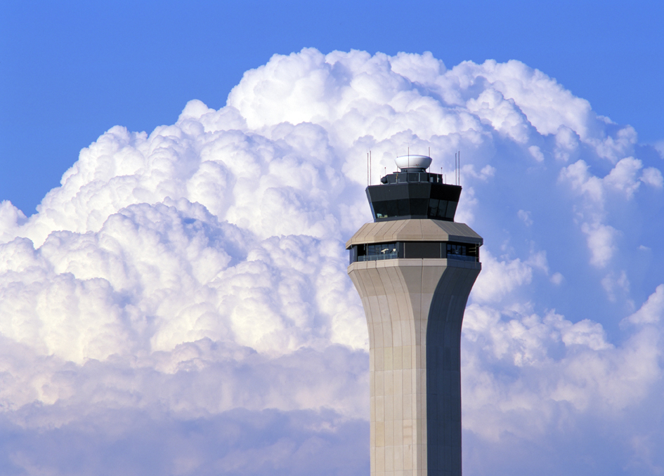

DISSOLVE TO:

The lining of shapeless clouds—from the cloud formation—

DISSOLVE TO:

INT. D.I.A. - CONCOURSE GATE A - ALMOST 10:07 AM MST

The briefcase—Michael once again holds it tightly. He emerges from the A-gate, jet-bridge into the concourse.

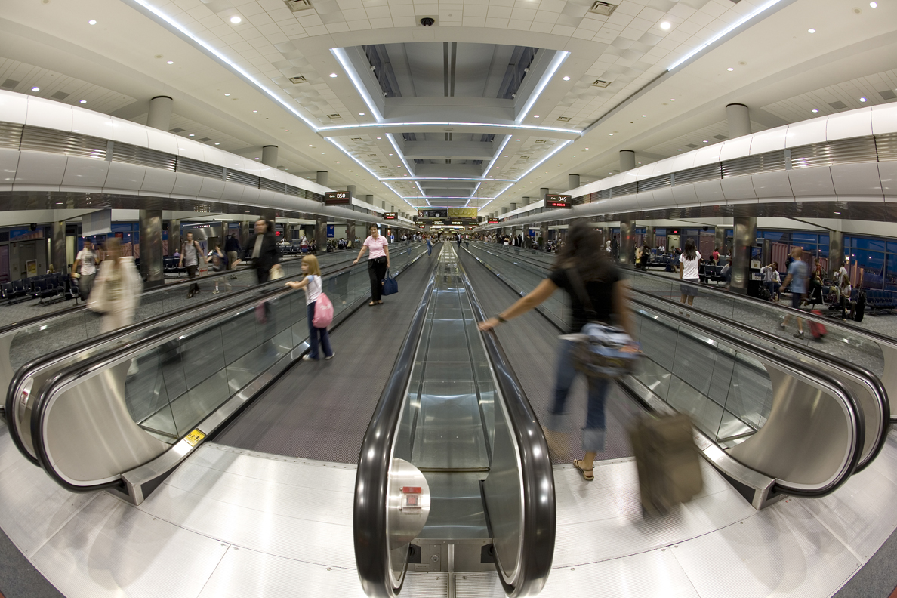

CUT TO:

H-GATE ATTENDANT
Denver International Airport
welcomes the unscheduled arrival of
flight 2321 from Chicago, Midway.

Maggie, in a snippety mood, steps into the concourse.
She comments to the attendant:

MAGGIE
“Windy City?!” Blow it out your ass!
I’m not good with geology, but Denver
better be on the way to San Francisco.

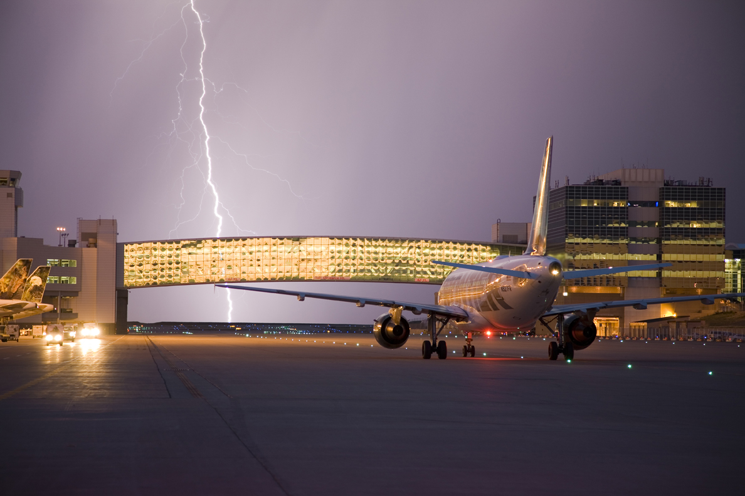

CUT TO:

AGENT #2
Will the passengers arriving on
outbound flight #2321 to JFK, New York—please temporarily remain
at Gate-L for further instructions.
Thank you.

LINCOLN
(To L-Gate agent #1)
Lightning?! Ben Franklin’s spinning
in his grave. You didn’t hear his
mother tell him to stop flying his
kite and come inside ‘cause of some
thunder!...A little electricity never
killed anyone. I’m willing to risk it.

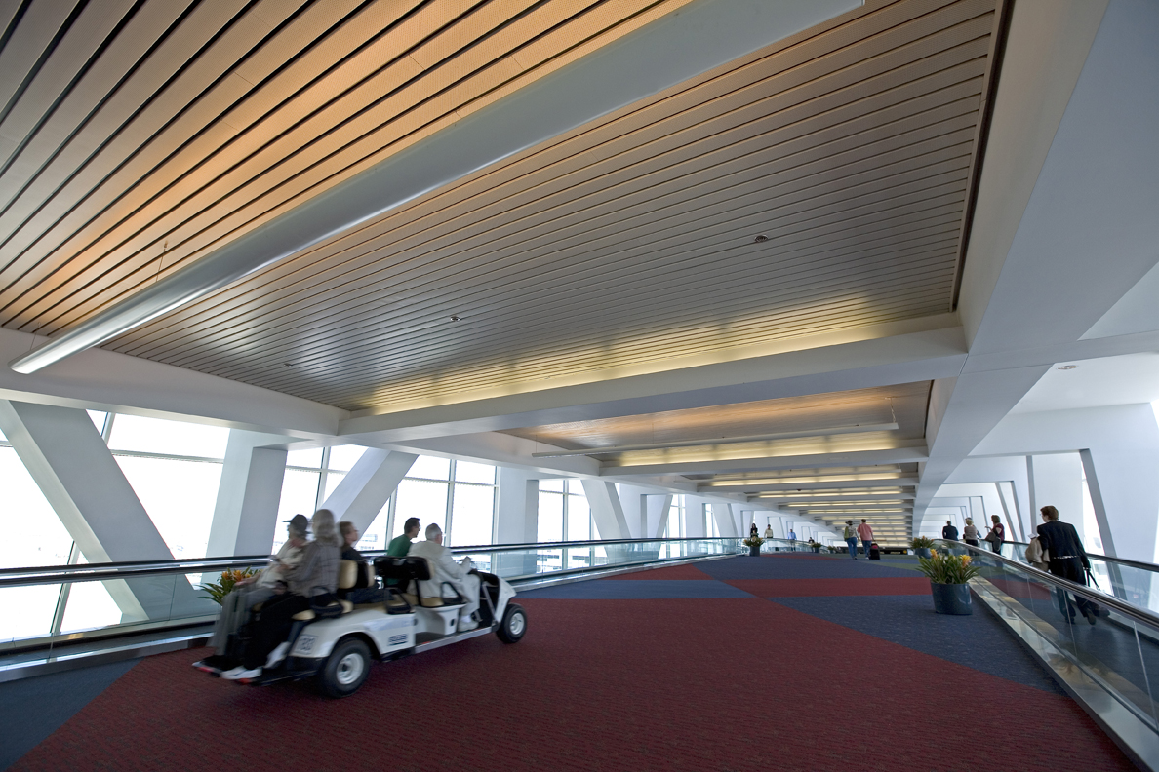

CUT TO:

E-GATE: At the bowels of the jet-bridge, a plane is docked. A friendly, young, black SKYCAP waits. The airplane door opens. From the initial first class seat, JUDY signals the skycap to roll a parked wheelchair to Aunt Mary Frances. With her Bible and a radio in hand, a weakened Mary crawls into the chair. The skycap rolls her off the plane. Judy, drunk, hollers into the cockpit:

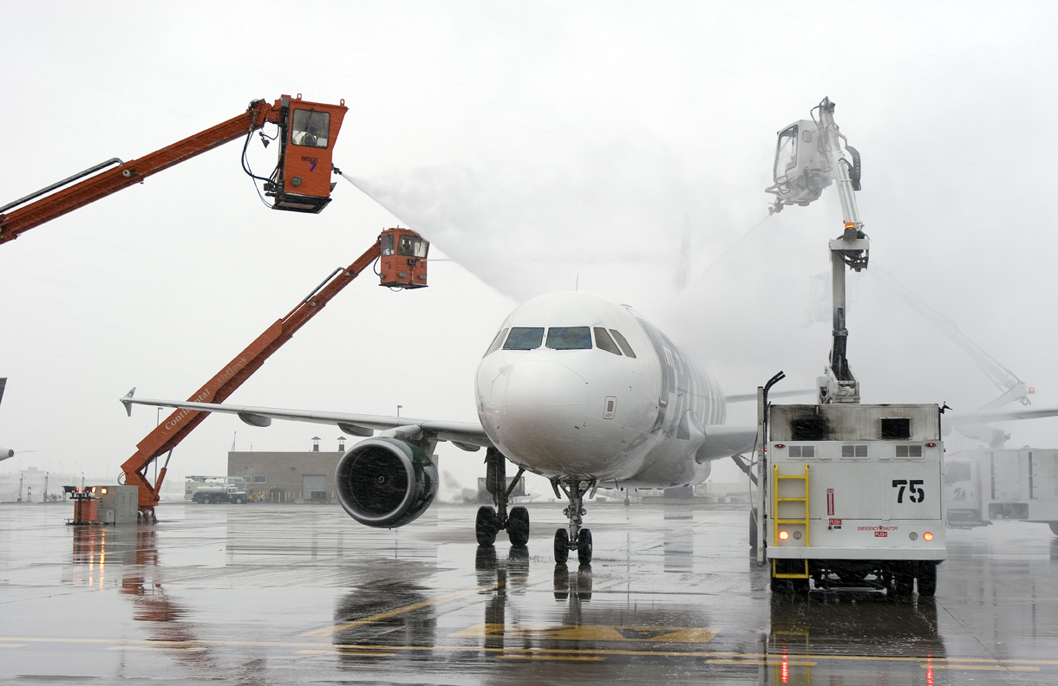

JUDY
Hail?! Hail Caesars!
I’ve seen less ice in my drink!

The end of the gangplank...they’ve reached the concourse. The E-GATE AGENT speaks over the MICROPHONE:

E-GATE AGENT (O.S.)
We will momentarily be boarding
passengers for the 11:18 departure at
Gate-E...Flight 2722: the continuation
of non-stop service to Las Vegas.

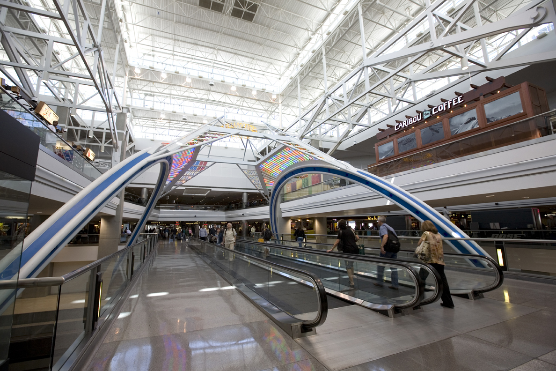

Michael looks back to the clock above the TV. It reads, 11:19. He hurriedly double-checks that next Verse from the Book of Revelation. He drops the briefcase at his feet. He falls to his knees in reverence.

MICHAEL (con’t)
11:19...“Then God’s temple in heaven
was opened, and the Ark of the
Covenant could be seen in the temple...”
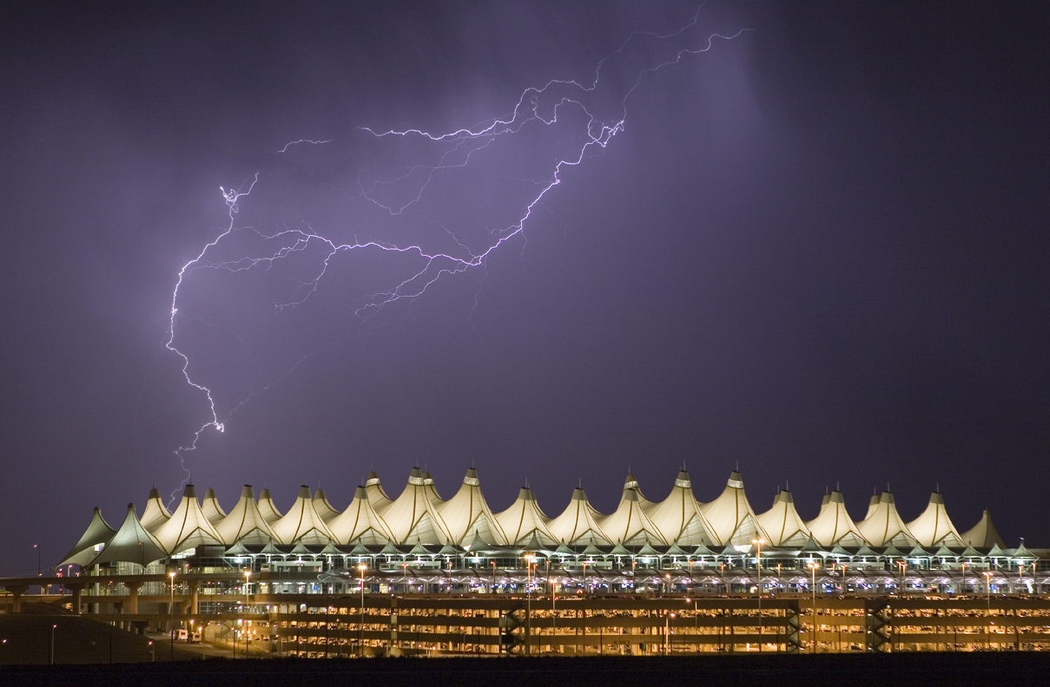
OUTSIDE THE WINDOW - We see SHOTS of the weather conditions.

MICHAEL (O.S.)
“...There were flashes of lightning,
rumblings, and peals of thunder,
an earthquake, and a violent
hailstorm.” An earthquake!

Michael throws his hands and head to the floor. He’s trying to feel a tremor.

MICHAEL (con’t)
My God! There’s gonna be an earthquake!
Everybody out! Save your lives!

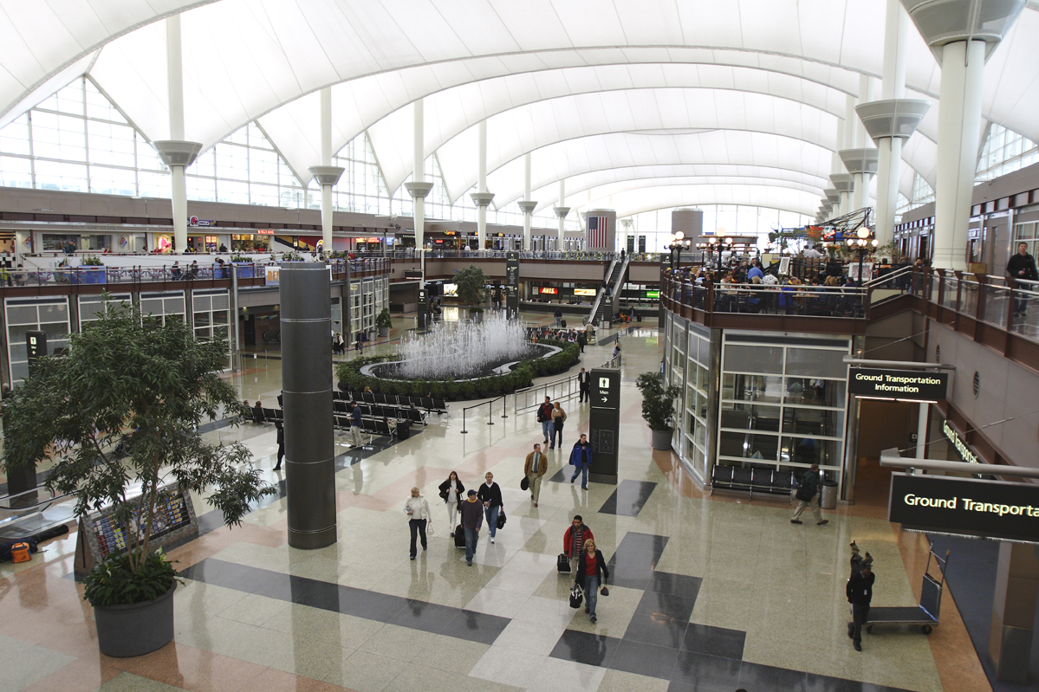

ANGLE ON:

A well-respected and decorated PILOT, rubbing dry his hands, emerges from the men’s room. He confronts the situation. To Michael’s defense, he asks of the guards:

PILOT
What has he done?

GUARD #1
We’re thinking of having him
arrested for inciting a riot.

The pilot looks around at the jeering travelers circled like headhunters. He succumbs and gives up his defense.
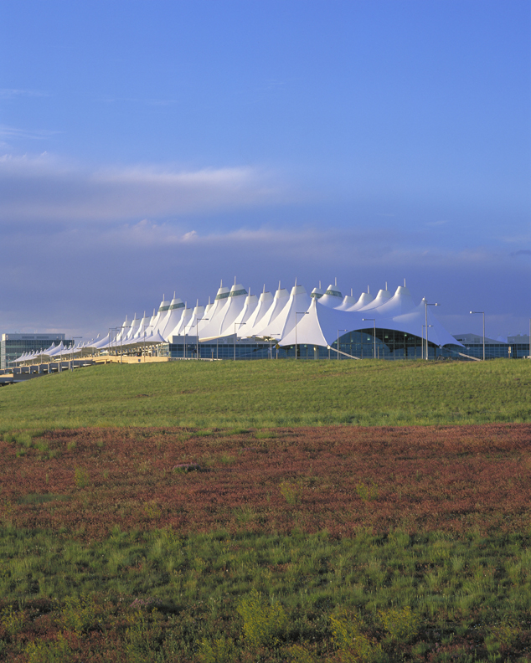
ANGLE ON:

Some of the people gathered are frozen in their tracks.

BACK ON MICHAEL - the bond strengthens between him and Mary. She holds his bloody forehead. A SHOT of the shaking chapel indicates the increased second tremor.

BOYFRIEND
It’s impossible! Go to Hell!
An earthquake in the heart of
the country?!

RHODA
He’s telling the truth!
Three times I heard him predict it!

Michael rests his head on Mary’s lap.

MARY
Son...now I can die in peace.

The earth moves! The chapel quakes!

GUARD #2
Run for your lives!
The ceiling is going to collapse!

GUARD #1
Earthquake!

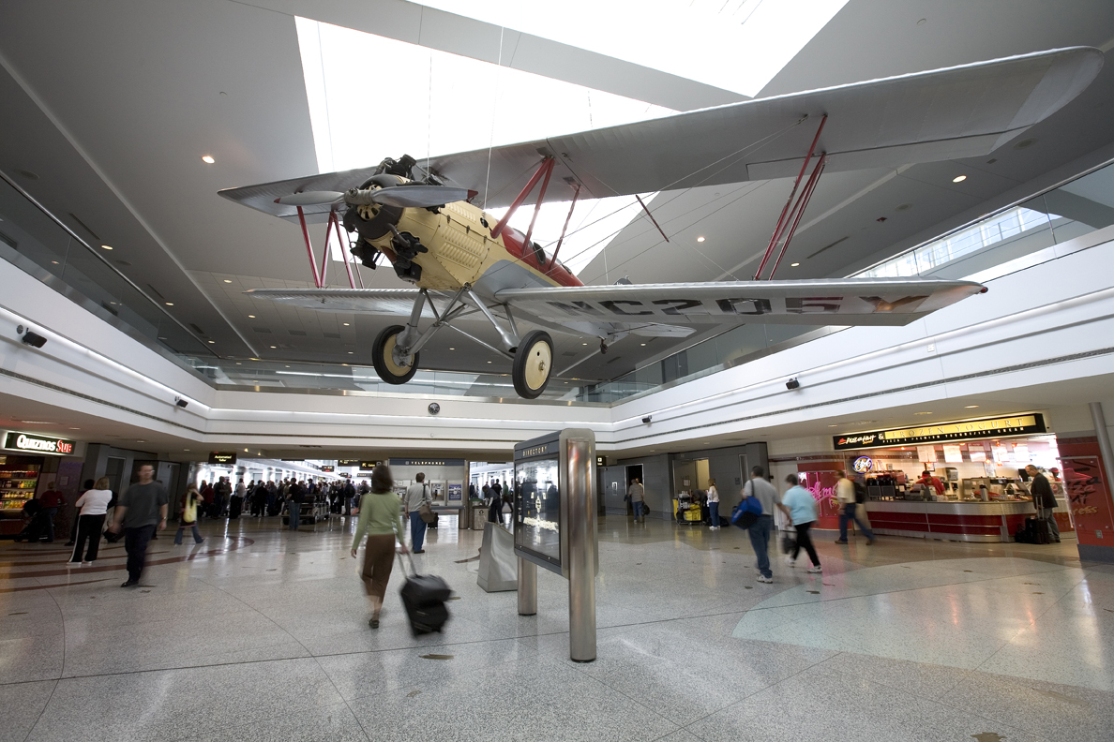
ANGLE ON – GATE-B:

In this area, 160 PEOPLE need to be saved. The L-gate agent #1 has been following the events from afar.

MICHAEL
Over there! The inflatable slide
ramp! Pull down on the middle
lever!

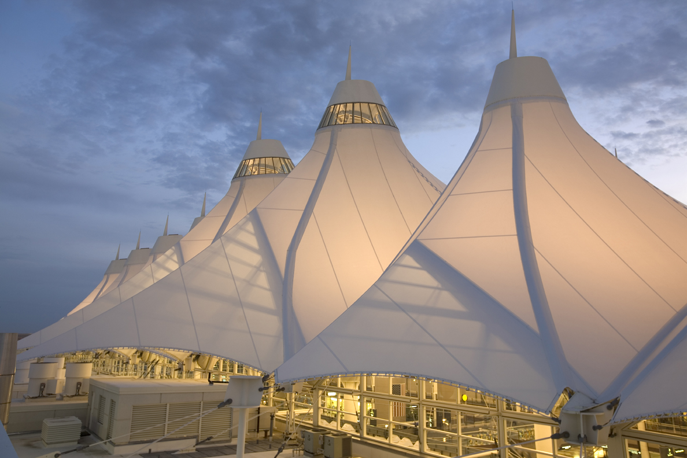

ANGLE ON GATE-C:

In this area, 80 PEOPLE need saving. The crumbling facade of the church does all but barricade the opened doorway. Rhoda runs to assist the effort.

MICHAEL
Please get those people into the chapel!
(He yells to them)
Follow what I say! The chapel will
save you! The crossbeams give it
support! It will not collapse!

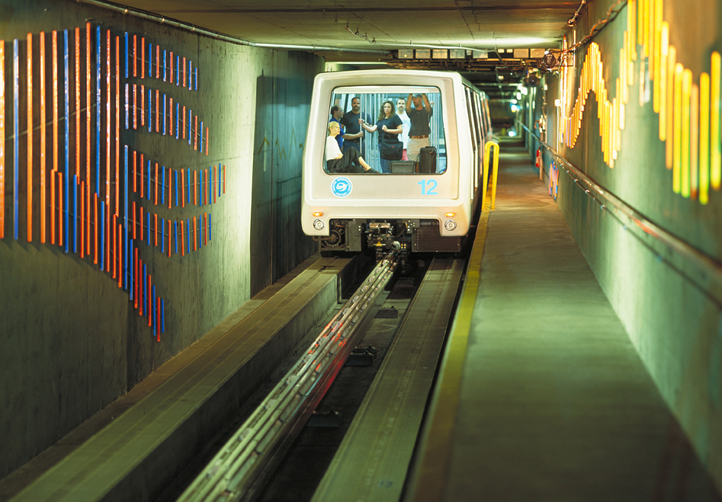

INT. CONCOURSE

Michael directs the group toward the next possible exit.

MICHAEL
Gate D! The AGABUS!

ANGLE ON - CONCOURSE AREA - GATE D:

In this area, 40 people need saving; particularly,
the 40 FEMALE MEMBERS of “Mothers Against Drunk Driving: M.A.D.D.” The group is aboard the “people transporter.” The official markings on the transport vehicle read:
AIR-GROUND ARRIVAL BUS—“AGABUS.”

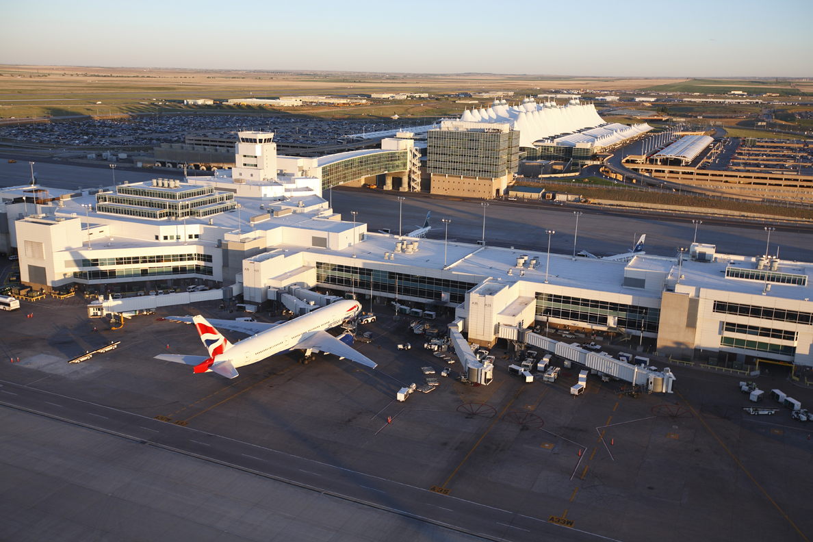

ANGLE ON - GATE E:

In this area, 20 PEOPLE need to be saved. With nowhere
to run for escape; the travelers are huddled around the narrowly opened, debris-riddled, jet-bridge entrance.

MICHAEL
Tell the attendants to get everybody
back on this flight—you’ll
be safe off the ground. Please
follow what I say! Listen to me!
I’m telling you the truth!
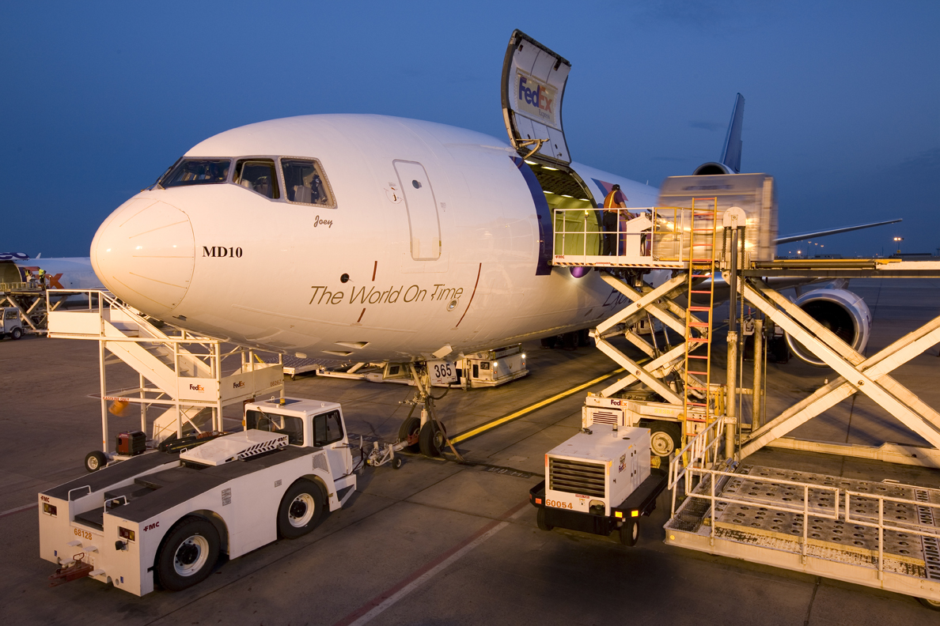

ANGLE ON - GATE F:

In this area, 9 INTERNATIONAL TOURISTS and a uniformed, Asian, male BAGGAGE HANDLER need saving.

CU - Michael grasps a suitcase handle. Like an ancient Olympian, he hammer throws it just short of the belt.
The baggage handler places it on the belt.

MICHAEL
Here! Here, one at a time!
This conveyer belt unloads into
a carrier truck outside of the
airport....Get on a case, it will
cushion the landing.

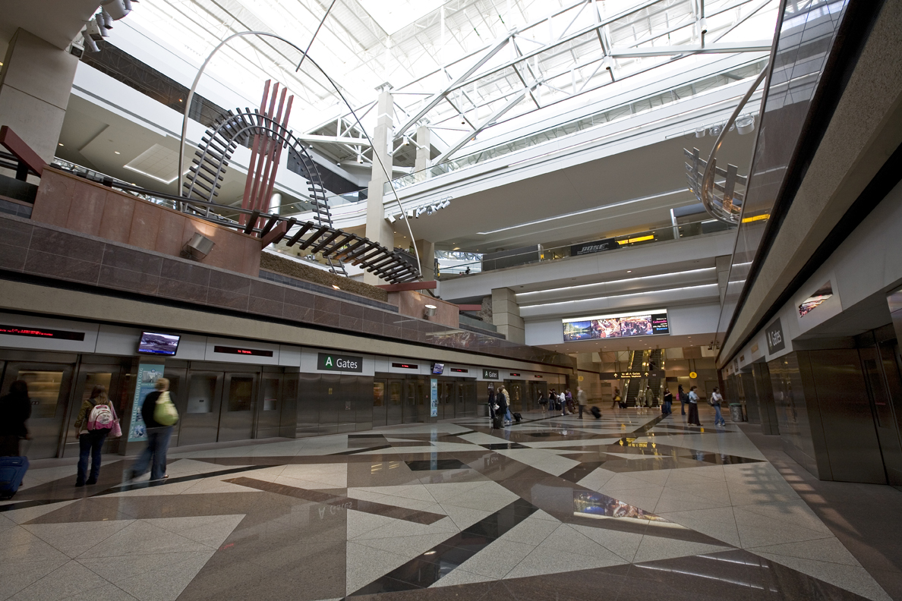

ANGLE ON - CONCOURSE AREA - GATE G:

FROM ERNIE’S POV - He sees a broken sign above GATE-G that reads: TRAIN ENGINE

ERNIE (O.S.)
The train...this way!

JUDY (To Ernie)
You bumbling...it doesn’t say train—
it says “training!” It says: Air N’
Ground...A-N-G-E-L...Angel, you idiot!

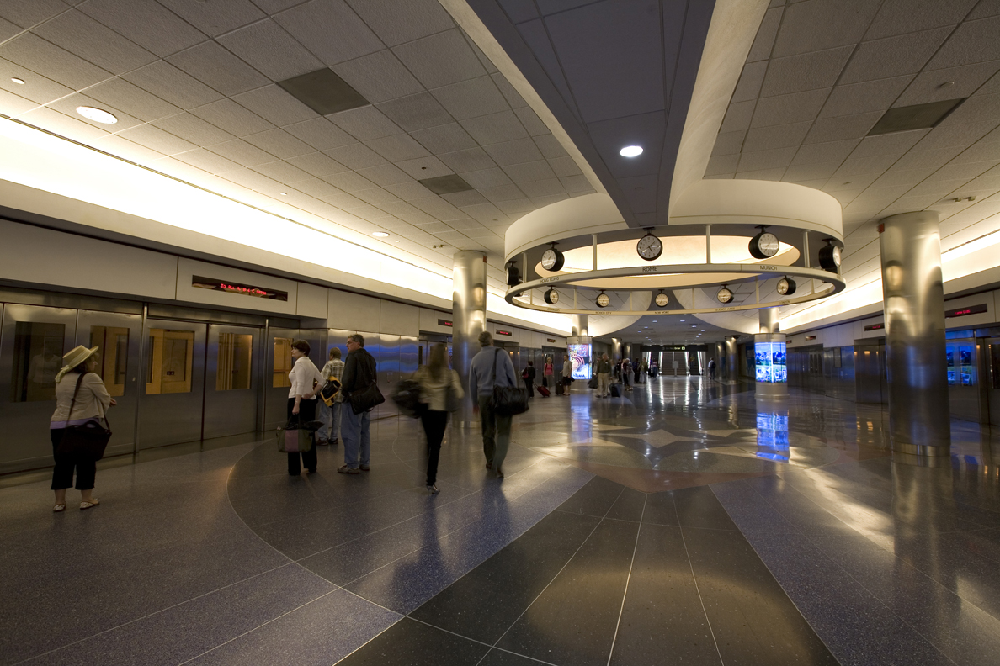
FROM JUDY’S POV - GATE K: The radio station’s van rotates on a display spindle. Only Judy can see the gambler inside the van’s open panel door. On his knees, he waves her in.

Ernie holds the ax handle like a staff.

ERNIE
All aboard that’s going aboard!

JUDY
(forewarning Maggie and Lincoln)
No way in Hell! That’ll be suicide.
I’ll be damned!

Judy runs for the van as the earth tremors. Shards of ceiling fall in her wake but do not strike her.

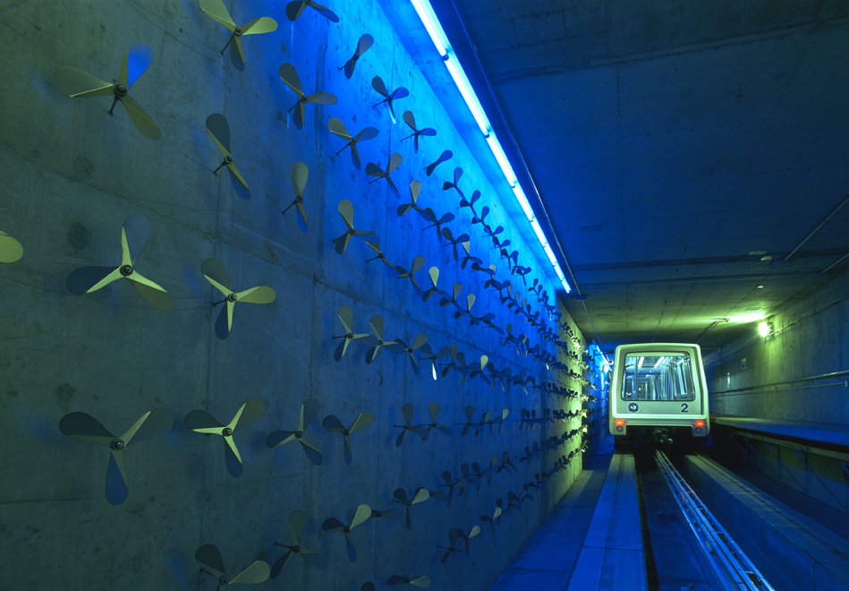

FADE IN SLOWLY:

INT. THE UNDERGROUND RAIL - BENEATH THE TERMINAL – CON’T

SLOWLY - we see the rolling motion of the wheels. Ernie was right. It is a locomotive engine; an experimental turbine-electric car similar to a theme park monorail.

INT. TRAIN

Ernie mans the control panel. He accelerates clear. Clenched against the wall, Lincoln and Maggie are scared stiff. There are fuel tanks and complex equipment onboard. The back of the train is opened like a tractor-trailer. Michael moves up a hatchway to a second level.

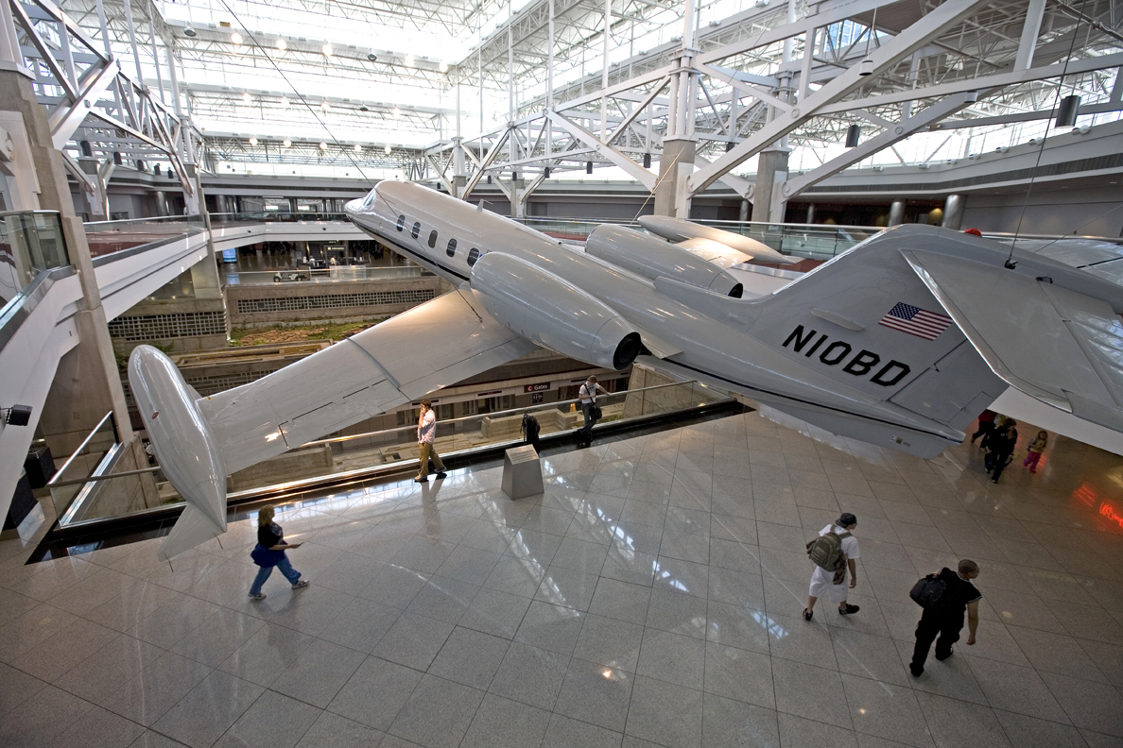

INT. THE A.N.G.E.L. COCKPIT - STILL INSIDE THE TERMINAL

Michael stands inside the A.N.G.E.L: an experimental, prototype aircraft that rides atop the train.

Stranded on an overhead trestle, partitioned by Plexiglas,
are N.B.A player MICHAEL JORDAN AND HIS TWO CHILDREN.

MICHAEL
Don’t be afraid!

Jordan holds his kids. Before Michael can assist, they jump into the cockpit from the glass.
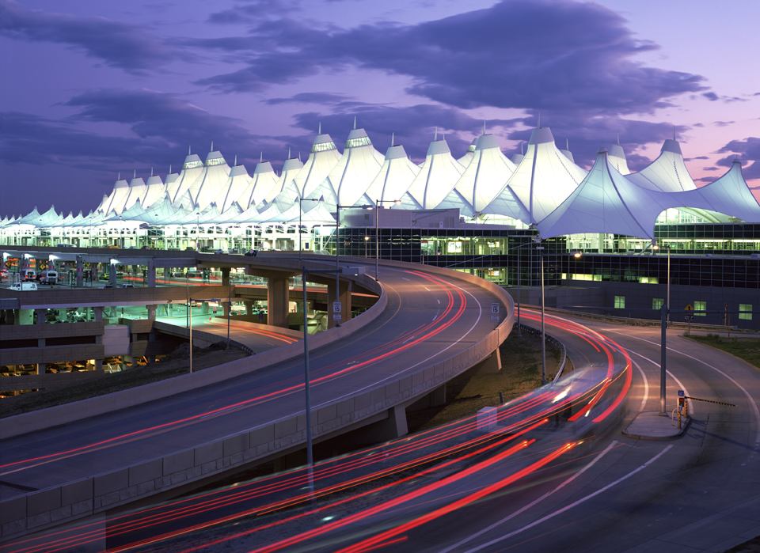

FROM MICHAEL’S POV - The train exits.

Ernie pulls the brake handle. Warning lights FLASH AND SOUND. Everybody stands still. The train has not stopped!

ERNIE
Hold on! The fuse blew...
the brakes are...!

EXT. THE MOUNTAIN TRACKS

The train/plane looks like a nymph as it rolls through beautifully destructive, earthen landscape.

EXT./INT. THE A.N.G.E.L. OPEN-AIR COCKPIT

Jordan leaps high into the cargo net. Michael lunges,
but can offer no physical assistance.

EXT./INT. THE A.N.G.E.L. COCKPIT

Michael follows Lincoln out of the hatch. They move to the edge of the craft to see the chairlift. Lincoln slides safely to the guide-way. Sparks fly as the cross rides the metallic rail.

EXT. THE TRAIN

Exiting from out of the chamber, Maggie pours out of the spout. The umbilical cord of a chute winds into the station box. The box looks like a large, portable john.

EXT. THE GORGE - A HELICOPTER SHOT

We see the span in the earth. The train trestle is severed in half. The bridge is out!

INT. TRAIN

The fallen oak halts the train. The CAMERA FOLLOWS Ernie as he’s ejected out of the windshield. He’s thrown into the last tree at the gorge’s edge.

EXT. THE GORGE

The plane glides over the gorge. From the structural wreckage of the bridge, in the center of the geological gap; a large, wooden cross protrudes. Michael releases
the rope. It falls, like a snake, into the train wreckage. He lets go of the case. It drops onto the bridge below. He reaches out for the crossbeam. Like a trapeze artist, he swings onto it. A weathered, wooden plaque reads: FOUNTAIN RIVER. The A.N.G.E.L. continues out of sight into the waters below. We hear a screaming voice...

NOAH (O.S.)
Save me a place!

THE CAMERA TILTS UP - on Noah’s body, from his foot to his hands. He clings to Michael’s feet. He sheds Michael’s shoes and pants trying to scale up him. The pants blow onto the scaffolding. Michael’s left only in his briefs—Noah holding his feet. SLOWLY UP MICHAEL - we see blood dripping down his chest, arms, and face. He’s in great pain. The sign above his head is more easily read:
FOUNTAIN RIVER. Noah fears his own death is imminent.

IN A FULL SHOT – Michael moves his torso like a pendulum. He’s trying to swing Noah safely onto the scaffolding.

MICHAEL
It is finished.

XCU - His hands release from the cross. Long wooden splinters have pierced his palms.

FADE TO WHITE FOR A LONG MOMENT:

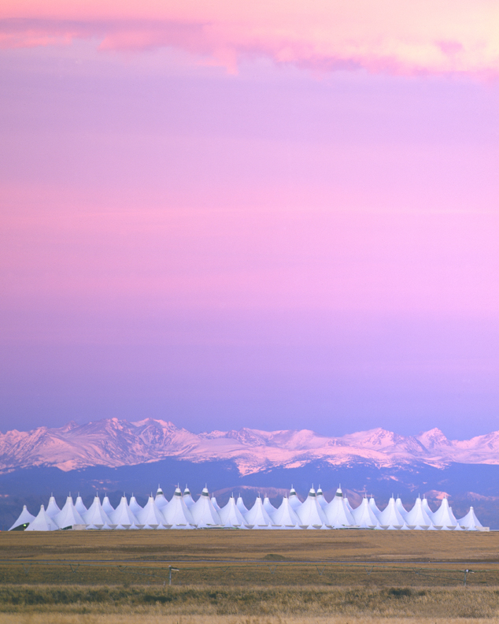

EXT. THE TERMINAL - THE GROUND TRANSPORTATION LEVEL - EASTER SUNDAY, APRIL 24, 2011 - SUNRISE

PULLING BACK - We see the white, concrete edifice is no more than a junk pile. A bronze sign has fallen in the b.g, it reads: ROMAN EMPIRE BUILDERS MCMXCIX.

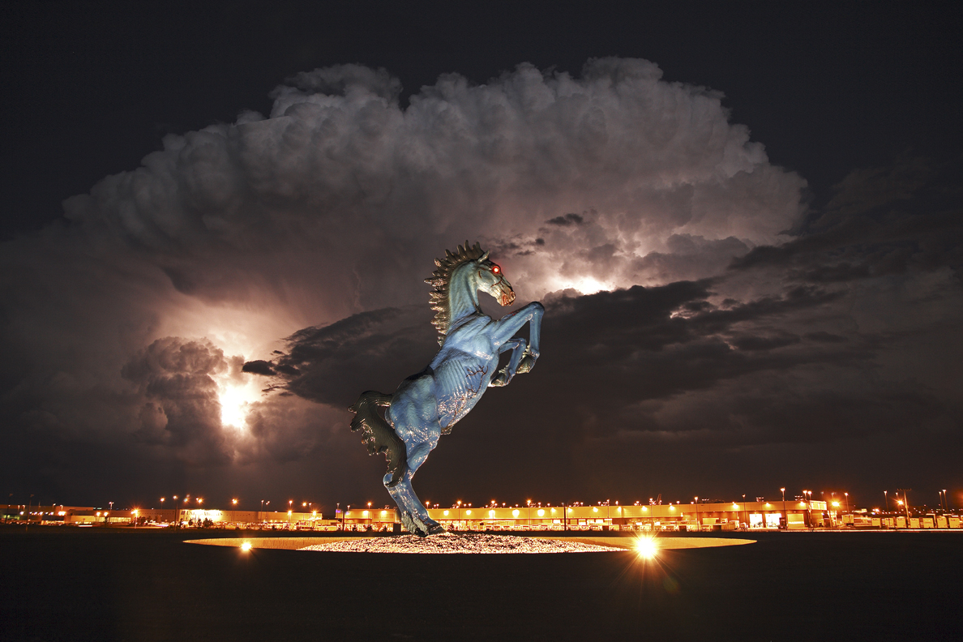

EGINS
The CAMERA FOLLOWS the childlike drawing of a horse in
the gust. A magnificent, wild, WHITE HORSE rises to its hind legs at the peak of the heavenly mountaintop.
From a TILTED ANGLE - the horse whinnies in silence.

MICHAEL (O.S.)
“And war broke out in heaven:
Michael and his angels fought
with the dragon; and the dragon
and his angels fought,
but they did not prevail,
nor was a place found for them
in heaven any longer.”

Denver International Airport Confirmation:  Public Relations and Marketing  8500 Peña Boulevard  Denver, Colorado 80249  Main Office: (303) 342-2250  Telefax: (303) 342-2266  E-mail: marketing@flydenver.com | Contact:  Mark Anthony DiBello  310-717-2440  E-mail: markanthonydibello@yahoo.com

