
“A Passion for the Ponies” Reality Television Series Treatment
-This reality docu-drama is a cross between “Biography” and “Lifestyles of the Rich and Famous” in the ultra-luxurious, high-priced and competitive world of thoroughbred horse-racing.
-Or…this reality-drama, similar to HBO’s “Hard Knocks” NFL football training camp series, chronicles the high-priced and competitive world of thoroughbred horse-racing at the family stable or racing organization of _____________.
-Or…is a NY-based, at Saratoga Race Course (the oldest organized sporting venue of any kind in the United States), Belmont and Aqueduct; reality-TV series featuring the most prized characters in reality TV: New Yorkers.
In each scenario, is seen the fascinating but here-to-fore unpublicized stories of how owners built their fortunes or stakes and then why each invests, or purchases, even adopts a racehorse and their results; in a sport that each calls their life’s dream, lifeblood, or “passion.”
Actually, this game has been called: “The Sport of Kings.” In fact, Paris and Versailles are not only in Europe, but home to some of the most grandiose horse farms in all of Kentucky Bluegrass Country. Some even think the grace and beauty of a queen or prince is no match for the splendor and sight of regally-bred equine specimen.
For centuries, thoroughbred horse racing has been a passion for European royalty, like the Kings and Queens of England; American billionaires like Houston Texans owner Robert McNair; and Sheiks like Mohammed, the ruler of the oil-rich United Arab Emirates, but the racetrack was also the playground of the rich and famous long before actor Jack Nicholson or reality star Kim Kardashian attended a Lakers game. In fact, the premiere paparazzi shots or “photo opps” were of screen legends the likes of Gable, Grant and Garbo at Hollywood Park.
In this highest of stakes game, there have been sordid and dramatic stories like: the killing of horses for insurance pay-offs, high-stakes gambles and losses on races or sterile, slow-running stallions, and even the adulteries and murder of family members for inheritances! But there have also been feel-good, victorious moments like the everyman, Seabisquit uniting a nation; or the saving of a fallen champion like Barbaro and his owner’s the Jackson’s; or the group of $2,000 investors who won over $2,000,000 with a Kentucky Derby winner named Funnycide.
Truth be told, the horse racing industry is in dire need of publicity to attract a younger audience. Racetracks, themselves, like Hollywood Park in Los Angeles and Aqueduct in New York are losing attendance and many have been forced to close. It was once remarked, “The best paid advertisement is free publicity”; well if that is so, then the still-wealthy, “old-money” horse racing industry will come running to support this dramatic or reality-based program.

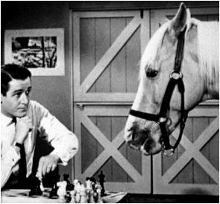
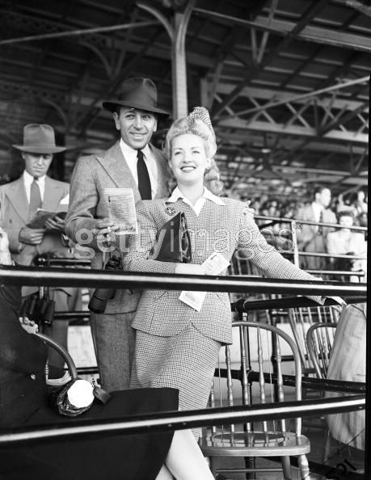
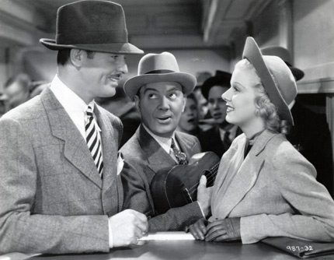


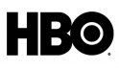
The TV hit, “Mr. Ed” Gable and Harlow in Saratoga. Raft & Grable at the track.




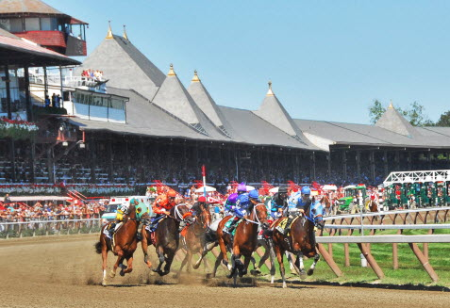
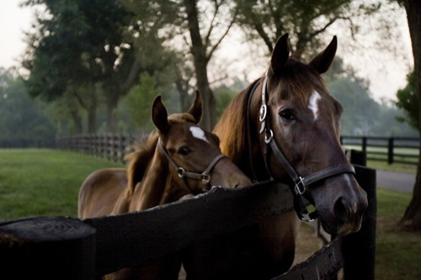



A 1 and 3 year-old 150 Year-old Saratoga
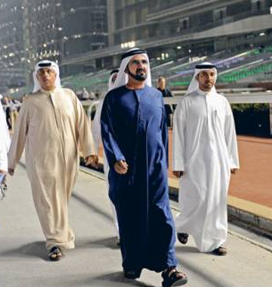

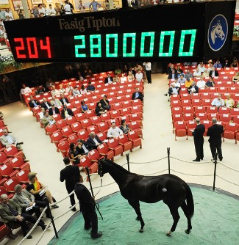

The Sheik buys Mohammed worth 12 Billion Entourage exits $2B track

